**DSP – Experiment 5 – Output**

**Cross correlation Output**

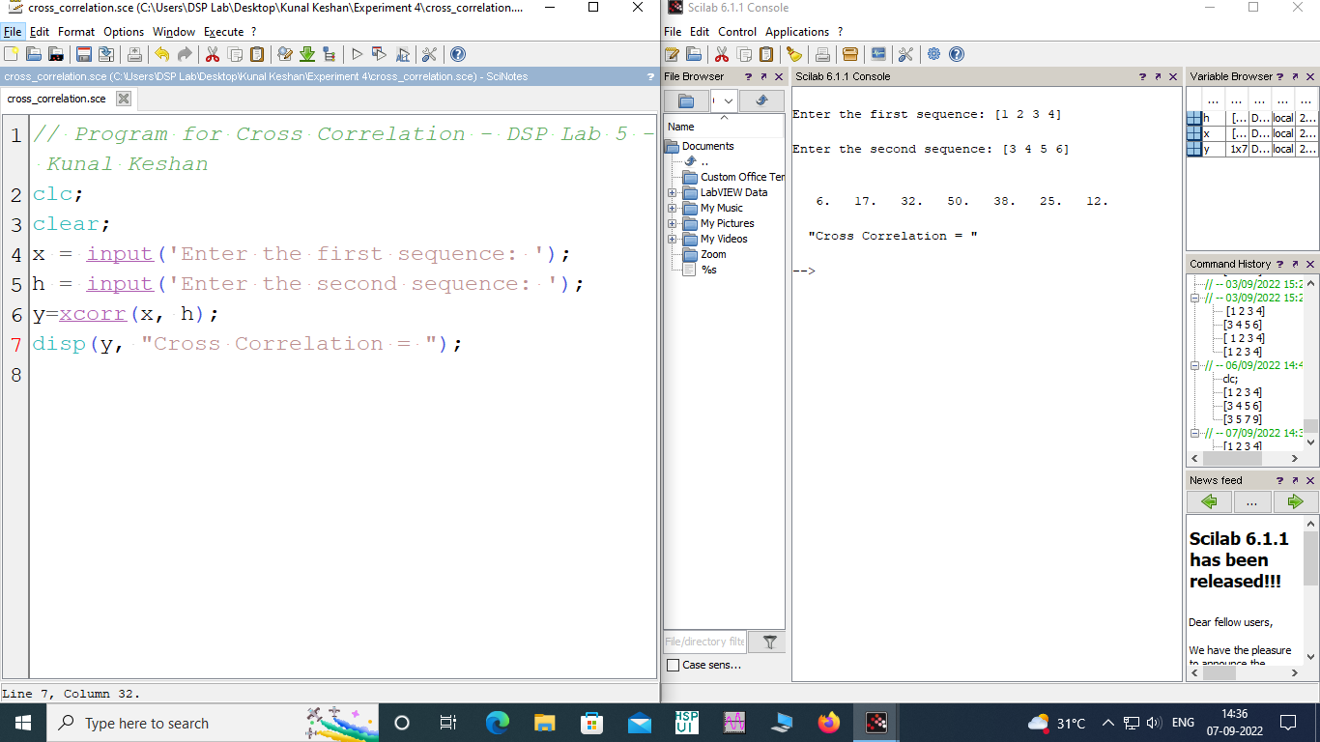

**Auto Correlation**

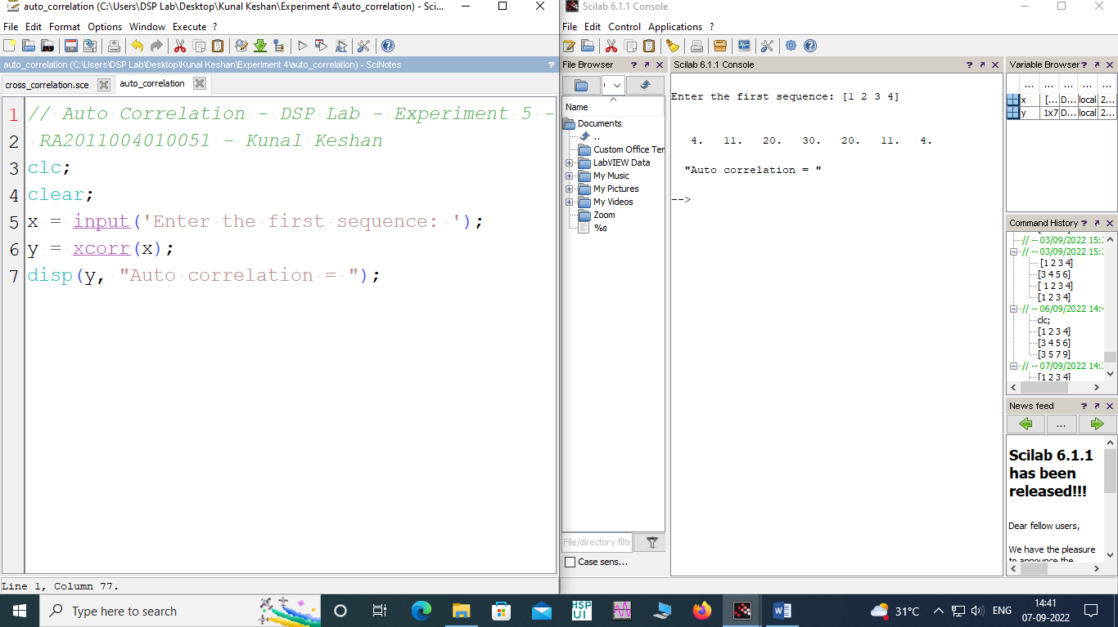

**Spectrum Analysis**

